Park Art - A View from Haregate
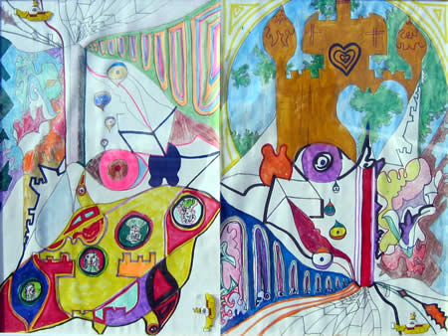
The Peak District Sustainable Development Fund (PDSDF) gave a grant to encourage both people from Haregate and regular Borderland Voices participants to learn more about the National Park on their doorstep. We tailored a programme of creative writing and expressive arts activities, many utilising local and/or sustainable materials such as willow and recycled fabric

